**History of computer**

Vacuum Tubes (1950s) - one bit on the size of a thumb;

Transistors (1950s and 1960s) - one bit on the size of a fingernail;

Integrated Circuits (1960s and 70s) - thousands of bits on the size of a hand

Silicon computer chips (1970s and on) - millions of bits on the size of a finger nail.

The progression of the ease of use of computers:

Almost impossible to use except by very patient geniuses (1950s);

Programmable by highly trained people only (1960s and 1970s);

Useable by just about anyone (1980s and on).

**Machine:**

computer is a programmable machine. The two principal characteristics of a computer are: It responds to a specific set of instructions in a well-defined manner and it can execute a prerecorded list of instructions (a program).

**Modern Computers Defined**

Modern computers are electronic and digital. The actual machinery — wires, transistors, and circuits — is called hardware; the instructions and data are called software

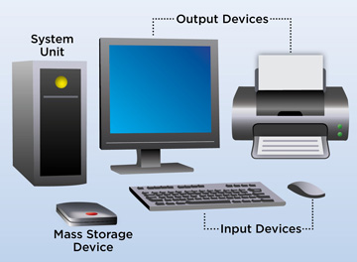

***Computer Classification: By Size and Power***

[**Personal computer**](https://www.webopedia.com/TERM/P/personal_computer.html)**:** a small, single-user computer based on a microprocessor. In addition to the microprocessor, a personal computer has a keyboard for entering data, a monitor for displaying information, and a storage device for saving data.

[**Workstation**](https://www.webopedia.com/TERM/W/workstation.html)**:** a powerful, single-user computer. A workstation is like a personal computer, but it has a more powerful microprocessor and a higher-quality monitor.

[**Minicomputer**](https://www.webopedia.com/TERM/M/minicomputer.html)**:** a multi-user computer capable of supporting from 10 to hundreds of users simultaneously.

[**Mainframe**](https://www.webopedia.com/TERM/M/mainframe.html)**:** a powerful multi-user computer capable of supporting many hundreds or thousands of users simultaneously.

[**Supercomputer**](https://www.webopedia.com/TERM/S/supercomputer.html)**:** an extremely fast computer that can perform hundreds of millions of instructions per

**Is robots/Machines could replace Humans?**

Robots could replace humans in a quarter of us jobs by 2030, about 30Millions jobs could be at risk of automation, according to a new report.

Robots will replace doctors by 2035 and replace human teachers.

An AI takeover is a hypothetical scenario in which AI become to the dominant form of intelligence on earth with computers and robots effectively taking the control of the planet away from the humans species but still machines are not accurate enough and always need humans to operate.